#CTS NURTURE 4.0_ JAVA FSE:

#WEEK 3

#EXERCISE 2:

#HEALTH TRACKER

# DietPlan.java – (in com.ctsnurture.model)

package com.ctsnurture.model;

import org.springframework.stereotype.Component;

@Component

public class DietPlan {

private String mealTime;

private String dietType;

public DietPlan() {

this.mealTime = "8 AM, 1 PM, 7 PM";

this.dietType = "High Protein, Low Carb";

}

public void displayPlan() {

System.out.println("Meal Time: " + mealTime);

System.out.println("Diet Type: " + dietType);

}

}

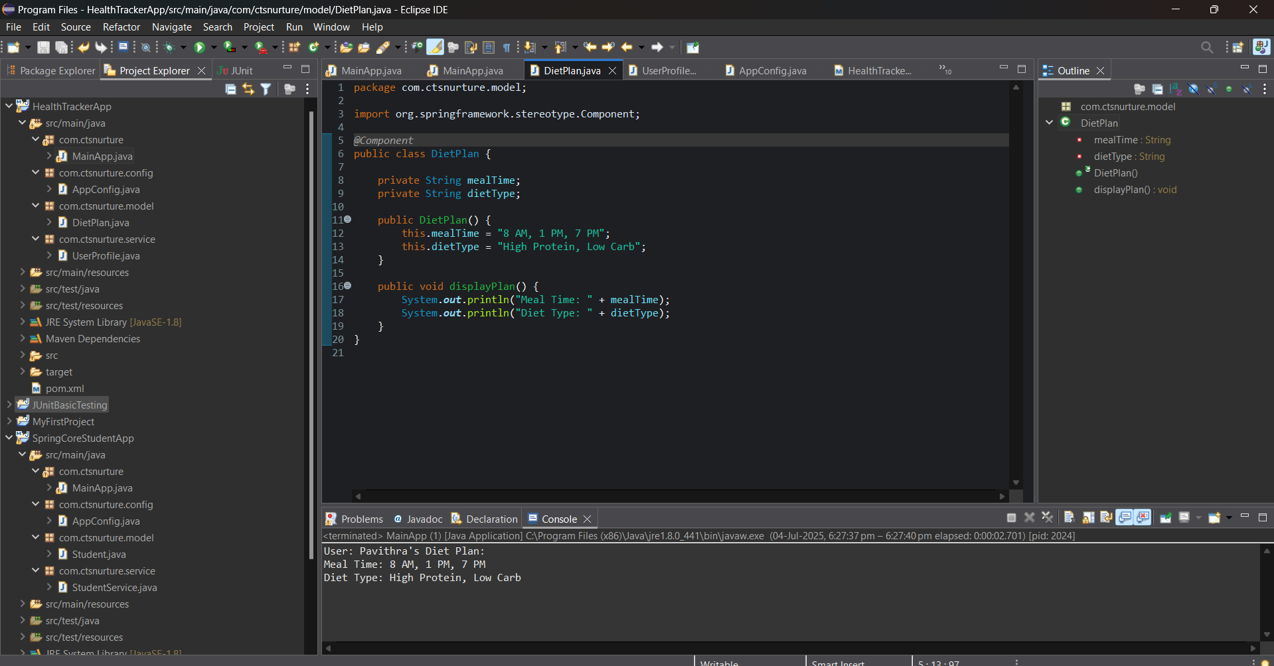

# UserProfile.java – (in com.ctsnurture.service)

package com.ctsnurture.service;

import com.ctsnurture.model.DietPlan;

import org.springframework.beans.factory.annotation.Autowired;

import org.springframework.stereotype.Component;

*@Component*

public class UserProfile {

private DietPlan dietPlan;

// Constructor Injection

*@Autowired*

public UserProfile(DietPlan dietPlan) {

this.dietPlan = dietPlan;

}

public void showUserDiet(String name) {

System.***out***.println("User: " + name + "'s Diet Plan:");

dietPlan.displayPlan();

}

}

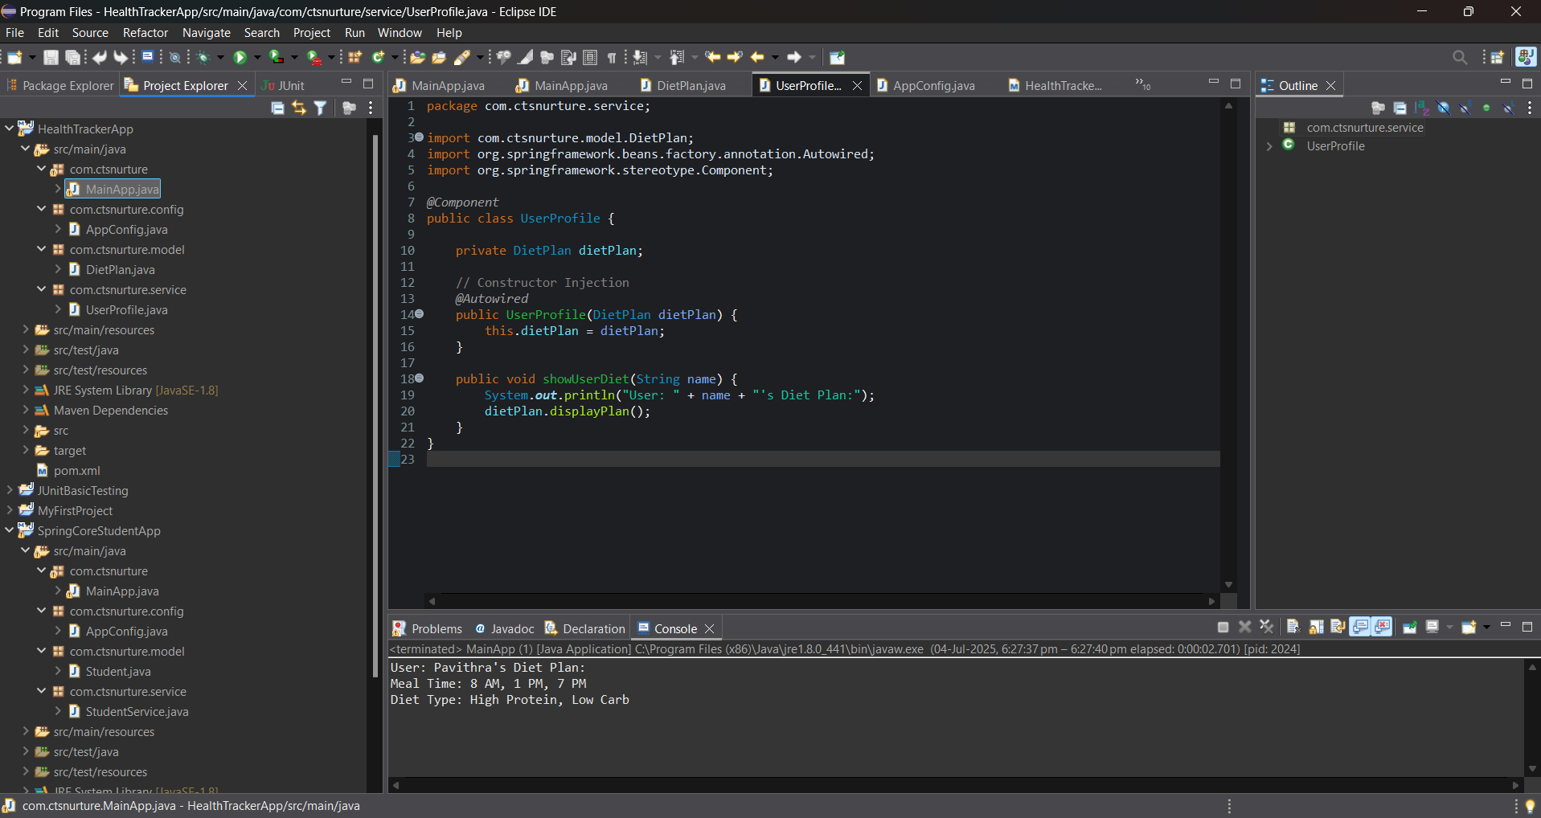

# AppConfig.java – (in com.ctsnurture.config)

package com.ctsnurture.config;

import org.springframework.context.annotation.ComponentScan;

import org.springframework.context.annotation.Configuration;

*@Configuration*

*@ComponentScan*(basePackages = "com.ctsnurture")

public class AppConfig {

}

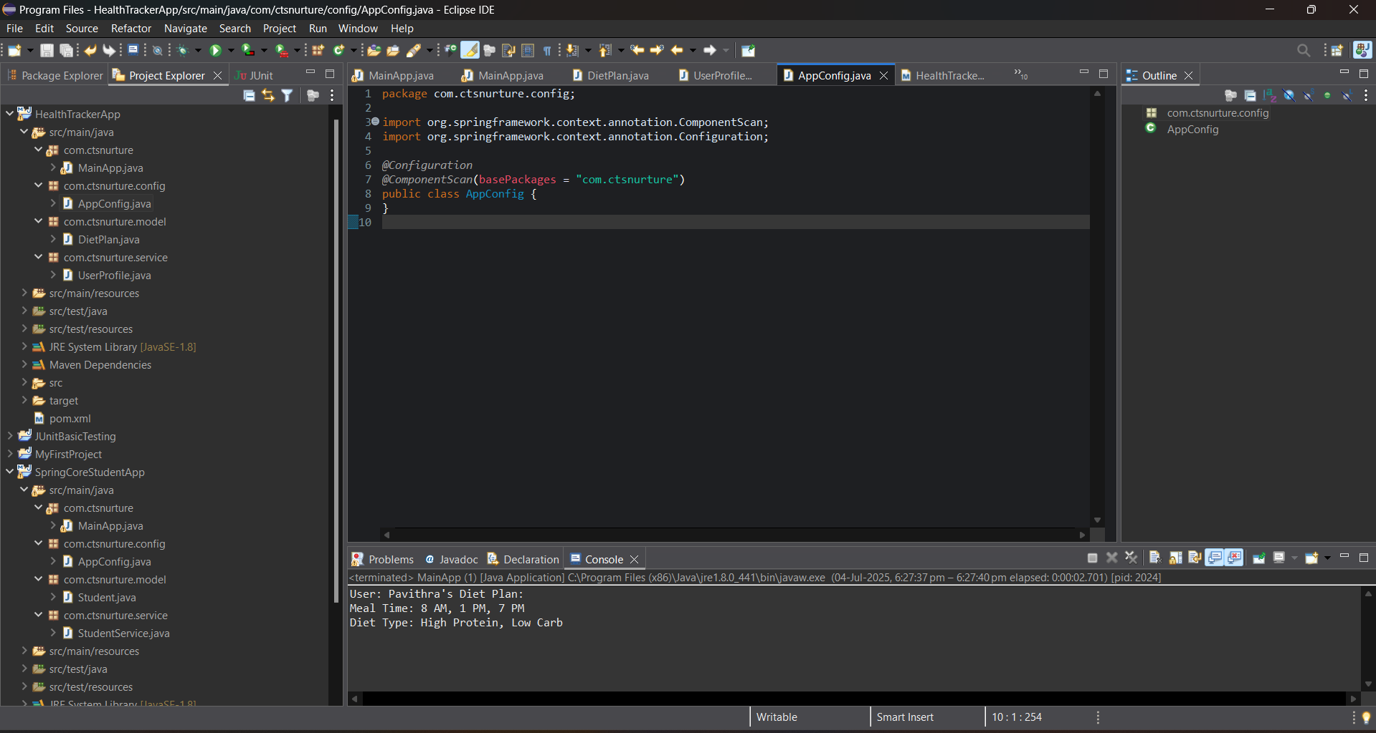

# MainApp.java – (in com.ctsnurture)

package com.ctsnurture;

import com.ctsnurture.config.AppConfig;

import com.ctsnurture.service.UserProfile;

import org.springframework.context.ApplicationContext;

import org.springframework.context.annotation.AnnotationConfigApplicationContext;

public class MainApp {

public static void main(String[] args) {

ApplicationContext context = new AnnotationConfigApplicationContext(AppConfig.class);

UserProfile profile = context.getBean(UserProfile.class);

profile.showUserDiet("Pavithra");

}

}

